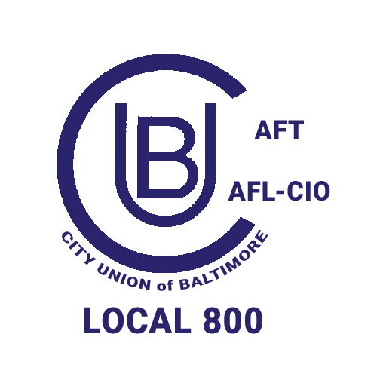
2026 City Union of Baltimore Nomination Petition
City Union of Baltimore Local 800 AFT, AFL-CIO

Steward worksite: ______________________________

Only CUB members are eligible to sign this petition

We, the undersigned nominate _______________________________________________________
____________________________________________________________________________________
(Print Name of Nominee) (Contact number)
as a candidate for the aforementioned elected position with the City Union of Baltimore.

Petitions must be received by the elections committee by Monday, August 10, 2026.

Submit to: CUB Elections Committee, 2117 N Howard St., Baltimore, MD 21218

Member name PRINT | Department/Location | Member Signature
1.

2.

3.

4.

5.

