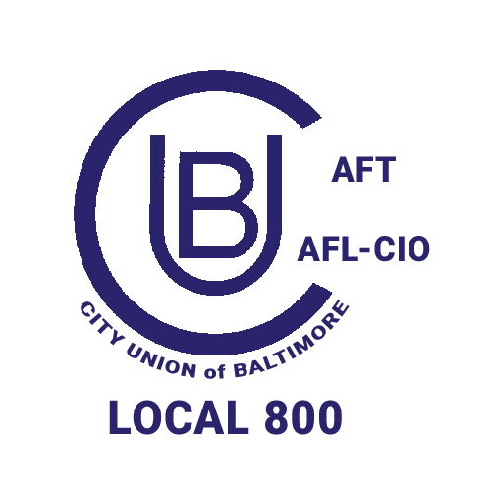
2026 City Union of Baltimore Nomination Petition
City Union of Baltimore Local 800 AFL-CIO

Executive Officer Positions

_____ President
_____ Vice-President
_____ Secretary
_____ Treasurer

Only CUB members are eligible to sign this petition.
50 CUB member signatures are required to be eligible for this office.

We, the undersigned nominate _______________________________________________________
____________________________________________________________________________________
(Print Name of Nominee and Contact number)
as a candidate for the aforementioned elected position with the City Union of Baltimore.

Petitions must be received by the elections committee by Monday, August 10, 2026.
Submit to: CUB Elections Committee, 2117 N Howard St., Baltimore, MD 21218

Member name PRINT | Department/Location | Member Signature
1.

2.

3.

4.

5.

6.

7.

8.

9.

10.

11.

12.

13.

14.

15.

16.

17.

18.

19.

20.

21.

22.

23.

24.

25.

26.

27.

28.

29.

30.

31.

32.

33.

34.

35.

36.

37.

38.

39.

40.

41.

42.

43.

44.

45.

46.

47.

48.

49.

50.

