AFT Masking Guidance for K-12, Higher Education and Public Employee Members
Not All Masks Are Created Equal

Reducing COVID 19 infection and exposure at work and school requires a comprehensive mitigation strategy. Masking or facial covering is one important mitigation strategy you can use to protect yourself from COVID-19. A robust testing program, contact tracing, enhanced ventilation and proper hand hygiene should remain in place along with clear metrics for workplace operating schedules.

At this point, cloth face coverings and surgical masks are not sufficient. Here is a list of masking options—from the most protective to the least.

- N95 Respirators
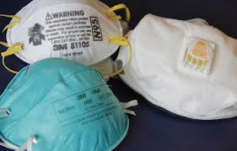
- N95 respirators work by filtering out contaminants and fit tightly to the face. They come in a variety of styles and sizes, but always have straps that go over the head, not ear loops.
- Check out ProjectN95 for information on where to find N95s and other respiratory protection.
- There are many counterfeit or fake N95s on the market. A genuine N95 will have a certification label certified by the National Institute for Occupational Safety and Health. Always check the label!
- If possible, try on different models to find one that fits you. It should fit as tightly to the face as possible.
- An N95 is not going to fit tightly to the face if you have facial hair.
- The Occupational Safety and Health Administration explains how to put on and remove the N95 safely, as well as how to check the seal. Putting on and Taking off a Mask - YouTube
- Disposable N95s are meant to be worn only once, but you may be expected to reuse them. At a minimum:
  - Never share an N95 respirator.
  - Avoid touching the front of the respirator, including when putting it on and taking it off, and wash your hands before and after wearing a respirator.
  - Take care in storing the respirator if you plan to reuse it. There isn’t a lot of guidance for reusing respirators but, at a minimum, store each in a clean, dry breathable paper bag for a minimum of 3
  - days before reusing. The paper bag will keep the respirator in a dry environment and give it time for the virus to be eliminated from it.
  - Do not continue to use an N95 if it gets soiled, crushed, bent or hard to breathe through.

- KN95s and KF94 Masks
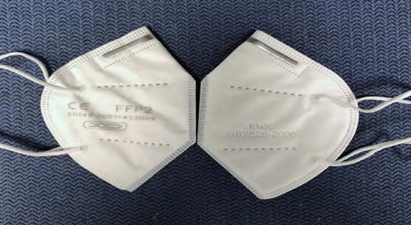
The next best option for protection may be a KF94 or KN95.
- These masks are more protective than medical procedure or surgical masks, but they are not as effective as an N95. They are made with the same filtering material as an N95, but they are not tight-fitting and have ear loops instead of the two head straps.
- BE AWARE: About 60 percent of KN95s in the United States are counterfeit (fake) and DO NOT meet NIOSH requirements.
- Look for a model that fits as closely to your face as possible, even though it cannot seal to the face like an N95.
- People using KN95s or KF94s should consider using them only once. Do not continue to use if it gets soiled, crushed, bent or hard to breathe through.
- KN95s and K94s can also be found on the ProjectN95 website.

- Masks with the ASTM 3502-21, Level 2 Label
Protective facial coverings approved by ASTM International is the next protective alternative.
- ASTM 3502-21, Level 2 Label is a class of masks that meet a scientific standard set by ASTM International, a standard-setting organization. Companies making these masks have earned independent laboratory verification that the mask meets breathability and filtration standards.
- Several companies make these masks, and they do not all look alike. It is important to look on the packaging for the ASTM 3502-21, Level 2 Label.
- The CDC has a list of approved ASTM masks, and they can also be found on the ProjectN95 website.
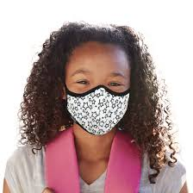
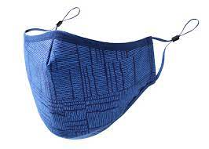
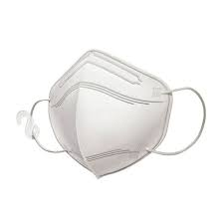

- Double Masking
If none of the above are available, it is important to double-mask to create more layers. Data is not available as to the effectiveness of this method so, if possible, leave this as your last resort.
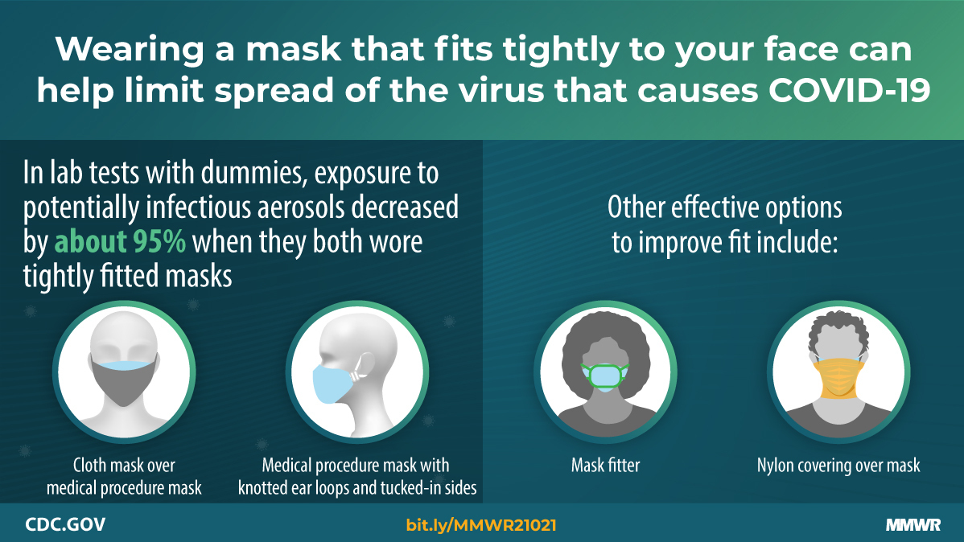
- At least one of the masks should be a disposable surgical mask with a metal clip to pinch over your nose.
- Try to cover any gaps around the nose and sides and around the bottom.
- Change your mask regularly, and wash your hands before putting masks on and after disposing.
- Do not continue to use any mask if it gets soiled, crushed, bent or hard to breathe through.

Project N95 is the National Critical Equipment Clearinghouse for personal protective equipment (PPE), COVID-19 diagnostic tests and critical equipment. They serve as a trusted and transparent resource, with established partnerships, comprehensive vetting processes and a mission to get PPE to people who need it as quickly as possible.
Steven E. Prince et al., “Assessing the Effect of Beard Hair Lengths on Face Masks Used as Personal Protective Equipment during the COVID-19 Pandemic,” Journal of Exposure Science & Environmental Epidemiology 31 (2021): 953-960, https://www.nature.com/articles/s41370-021-00337-1. Though variable, N95 respirators offer the best respiratory protection for bearded men. While KF94 and KN95 fitted filtration efficiency is compromised considerably by increasing beard length, they proved better options than procedure and cotton face masks.

